USOC/VOICE-Grade RJ12 Unshielded Keystone Jack

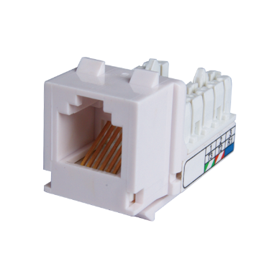

RJ12 Keystone jack is designed for voice-grade cabling.  Products are with Voice/USOC wiring instruction, Keystone snap-in footprint is ideal for all keystone type wall outlet and panels.  IDC is compatible with 110 as well as KRONE punch down tool.

Features

Large selection of colors, provides many options of color coded designation port

USOC wiring

UL Listed

KRONE/110 universal IDC design

Ordering Information

|  |  |
| --- | --- |
| PART | Description |
| 0AX6RP000-XX | RJ12, 8-Conductor Cat.3, KRONE/110 IDC, Unshielded, 180 degree, H.D. version |
| 1KX600000-XX | RJ12, 6-Conductor Cat.3, KRONE/110 IDC, Unshielded, 90 degree, H.D. version |

“XX” = color choices – ivory (IV), white (WH), gray (GY), black (BK), red (RD), orange (OR), blue (BL), green (GN), yellow (YL)